This is an open-book exam. You may use any resources except another person.

You may use your notes, your computer, your browser, Share Out, textbooks, etc….

Fill in your answers on this paper and submit it to the Desire-to-Learn dropbox within one week of the end of the course.

Name: _______________________________

Student Number: ______________________

|  |  |  |
| --- | --- | --- |
| **Question** | **Total Marks** | **Your Score** |
| 1 from lesson 1 | 6 |  |
| 2 from lesson 2 | 6 |  |
| 3 from lesson 3 | 6 |  |
| 4 from lesson 4 | 6 |  |
| 5 from lesson 5 | 6 |  |
| 6 from lesson 6 | 6 |  |
| **Total** | **36** |  |

Show all the HTML and JavaScript code to do the following (do not use jQuery):

Use DOM 0, in an external JavaScript file, to resize the width of the first image on the document to 100.

Include a JavaScript comment to include:

* Your name

Use a second type of JavaScript comment to include:

* A description of what the document, navigator, window, and style objects are

Use a third type of JavaScript comment to include:

* Your student number

# Question 2: From Lesson 2

Show all the HTML and JavaScript code to do the following (do not use jQuery):

At the end of the <body> section, using DOM 1, put a red solid 1px wide CSS border around all images.

Also: in the head section, after the window is finished loading, alert how many days are left until Christmas later this year.

# Question 3: From Lesson 3

Show all the HTML and JavaScript code to do the following (do not use jQuery):

Write a function that loops through all of a page’s hyperlinks and disables any link that has the word “bcit” in its href attribute.

Also, write code that prevents the following form from being submitted if its textbox is empty. Do not use jQuery:

<form action=”f.php”>

<input type=”text” id=”t”>

<input type=”submit”>

</form>

# Question 4: From Lesson 4

Show all the HTML and JavaScript code to do the following (**use jQuery**):

When the document is ready, put a red solid 2px red border around every image.

Show all the HTML and JavaScript code to do the following (**use jQuery**):

When an image is clicked, change its width attribute to 50.

Show all the HTML and JavaScript code to do the following (do not use jQuery):

When an image is clicked, change its width attribute to 50.

# Question 5: From Lesson 5

Show all the HTML and JavaScript code to do the following (do not use jQuery):

What is the JavaScript code to create the following page using only JavaScript (e.g. **document.createElement**, etc…):

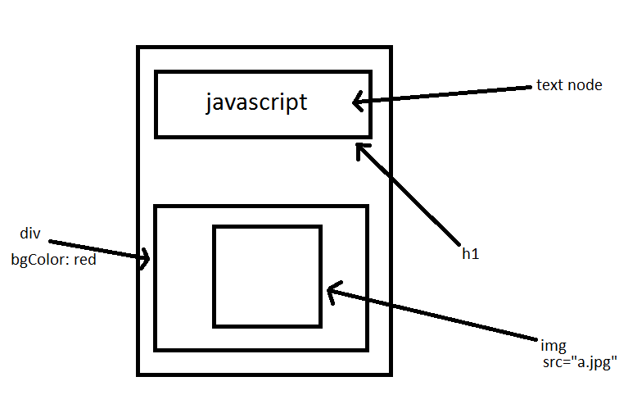

Also, show all of the code that would move an image with ID “x” one pixel to the right every 100 milliseconds.

# Question 6: From Lesson 6

Show all the HTML and JavaScript code to do the following (do not use jQuery):

Create a Book object with fields for title (e.g. “harry potter”), author (“jk rowling”), yearPublished (2000), and a function/method called readBook, which logs to the console “You’re a wizard, Harry”.

Use all four techniques we learned:

* Literal
* Constructor
* Constructor pattern
* Prototype pattern

Then use the for/in loop to display all enumerable data.